Harmol Kaur and Jigme Yeshey

User Manual

ACCIDENT DATA ANALYSIS APPLICATION

Table of Contents

1. Introduction: 1

2. Getting Started: 2

2.1 Installation instructions 2

2.2 Application Installation 2

3. Main Interface: 2

4. Functionality: 3

4.1 Analysing Accidents: - 3

4.2 Hourly Accident Trends 4

4.3 Accident Types Over Time 4

4.4 Alcohol-Related Accidents 5

4.5 Frequency Of Accident Types 5

5. Troubleshooting: 6

6. FAQs: 6

7. Conclusion: 6

8. Glossary: 7

# Introduction:

Welcome to the Accident Data Analysis Application! This user manual will guide you through the features and functionalities of this application, designed to help you analyze accident data effectively.

# 2. Getting Started:

## 2.1 Installation instructions

The Accident Data Analysis Application does not require installation. It is a Python-based application using the wxPython library. To run the application, make sure you have Python and the required libraries installed on your computer.

## 2.2 Application Installation

To start the application:

1. Open a terminal or command prompt.
2. Navigate to the directory where the application's Python script (**my_app.py**) is located.
3. Run the application by entering **python my_app.py** in the terminal or command prompt.

# Main Interface:

The main window of the application displays the title, “Victoria State Accident Dataset”, which is the name of the dataset being used to retrieve data. Under the dataset, there is the navigation bar, that includes the following buttons for accessing different features: -

* Accident: Retrieve all the data information within a specified time period.
* Accident Frequency: View hourly accident trends for a specific time period.
* Accident Types: Analyze accident types over time.
* Alcohol: Explore data related to alcohol-related accidents.
* Frequency of Accident Types: Examine the frequency of different accident types over time.

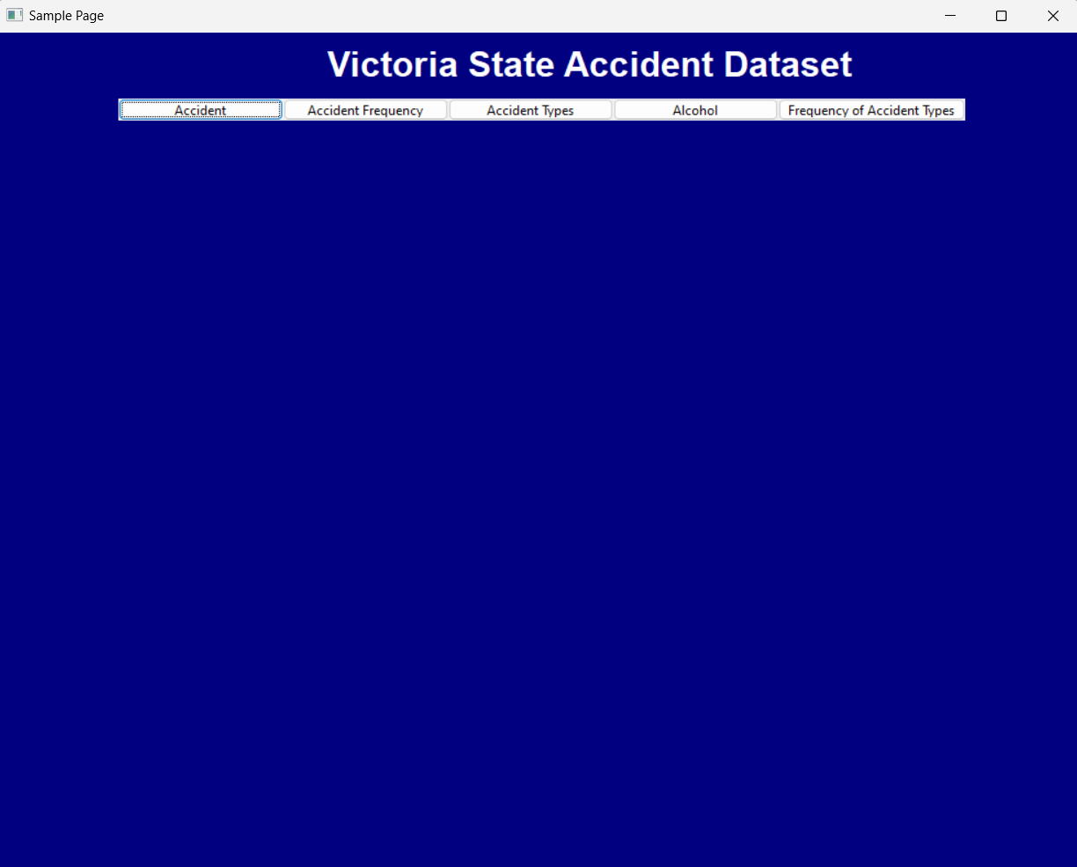

# Functionality:

## 4.1 Analysing Accidents: -

Accidents button is used to retrieve all the information related to the accidents occurred between the time period that you select. Follow the steps below to analyse accidents: -

1. Click on the “Accident” button in the navigation bar.
2. Click on from and till to get a drop-down date range. Select a date range (from and till) for the analysis.
3. Click the “Retrieve” button to retrieve and display accident data in a grid.

Look at the sample image below to see how retrieval of accident data happens:

## Hourly Accident Trends

Use Accident frequency button to check the hourly trends in the specific time period. Follow the steps below to get the chart for the accident

1. Click on the “Accident Frequency” button in the navigation bar.
2. Choose a date range and an hour of the day.
3. Click the “Create” button to generate a chart showing hourly accident trends.

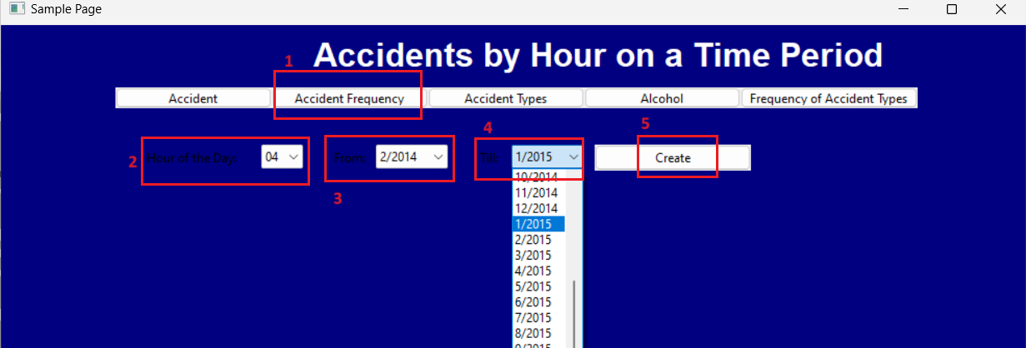

## Accident Types Over Time

1. Click on “Accident Types” button in the navigation bar.
2. Click on “Accident Type” to see list of accident types in a drop-down menu. Select the type of accident of which you want to retrieve the data.
3. Click on “From” and “Till” to select the date range for the accidents.
4. Finally, click on “Retrieve” button to see the list of data with the selected accident type over particular time period.

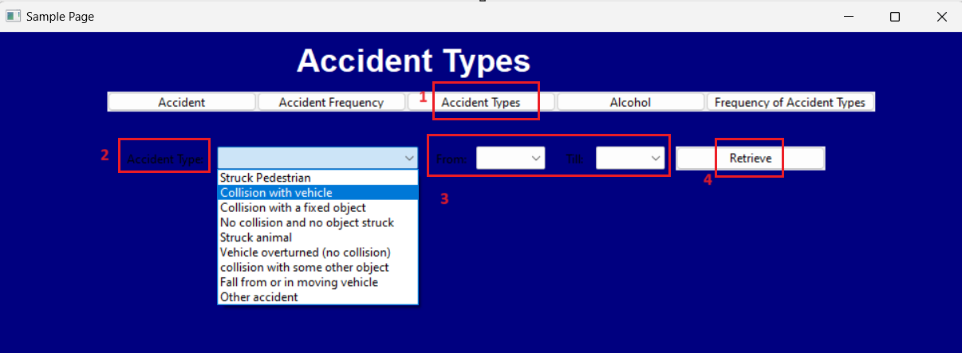

## Alcohol-Related Accidents

“Alcohol” button is used to see the trends of impact of alcohol on the accidents. To see how the trends have changed over time follow the steps below:

1. Click on the “Alcohol” button in the navigation bar.
2. Select a date range.
3. Click the “Create” button to visualize trends in alcohol-related accidents.

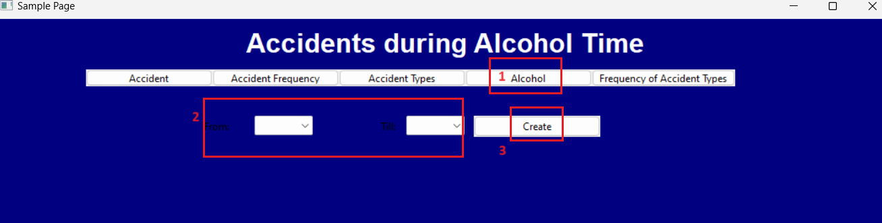

## Frequency Of Accident Types

Use the “Frequency of Accident Types” to compare how frequently the different accident types have occurred during the particular time period. Follow the steps below to make the comparative analysis: -

1. Click on the “Frequency of Accident Types” button in the navigation bar.

2. Specify a date range and an accident type.

3. Click the “Create” button to generate a chart displaying the frequency of the selected accident type over time.

# Troubleshooting:

In case you encounter any issues while using the Accident Data Analysis Application, here are some common problems and their solutions:

1. **Issue: Application Not Launching**

Solution: Ensure that Python and the required libraries (such as wxPython) are installed on your computer. Verify that you are running the correct Python script (my_app.py) from the appropriate directory.

1. **Issue: Data Retrieval Errors**

Solution: Double-check the date range and other parameters you've selected for analysis. Make sure they are within the available data range.

1. **Issue: Graph or Chart Display Errors**

Solution: Verify that you have selected the correct parameters for chart generation. If the issue persists, contact support for assistance.

# FAQs:

**Q: Do I need to install this application?**

A: No, the Accident Data Analysis Application does not require installation. It is a Python-based application.

**Q: How do I change the date range for analysis?**

A: When prompted, select the "from" and "till" dates from the drop-down menu.

**Q: Can I export the analyzed data or charts?**

A: Currently, the application does not support data or chart export. You can take screenshots for your records.

# Conclusion:

In conclusion, the Accident Data Analysis Application is a powerful tool for analyzing accident data effectively. It provides various functionalities to help you explore accident-related trends and statistics. We hope this user manual has been helpful in guiding you through the features and usage of the application. Your feedback is valuable to us.

# Glossary:

The Glossary section is meant to define any technical terms or acronyms used in the manual. Here's an example:

* **Python:** A high-level programming language used for developing applications like this one.
* **wxPython:** A cross-platform GUI toolkit for the Python language.
* **Data Retrieval:** The process of obtaining accident data from the dataset for analysis.
* **Hourly Trends:** Analysis of accident frequency over different hours of the day.
* **Data Source:** The origin of the accident dataset, providing information about where the data comes from.